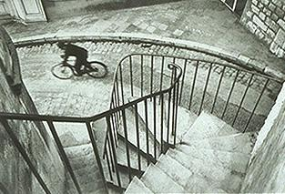
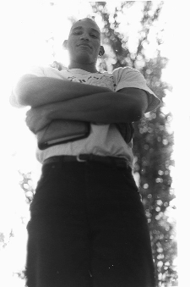
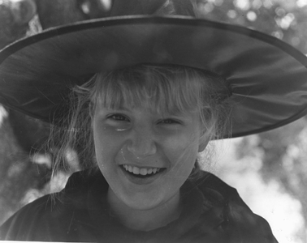

Assignment: The student will share a roll of film and shoot and develop it with the intent of capturing the 3 Views (High, Low, and Eye Level). The student will turn in 3-4” x 5” original prints, one for each of the 3 different Views. Rules of Composition & Design need to be observed to make the picture more creative.
Purpose: The students will learn the use of camera angles to enhance a subject. The use of the Rules of Composition & Design will be reviewed and used. The students will further show their mastery of the 3 Views by shooting and developing a roll of film with the intent of capturing each of the 3 Views in a original piece of work (picture). The students will show mastery by turning in one photo for each of the three views (Low, High, Eye). The Photo development and printing processes will continue to be used and mastered as they do the assignment.
CTE Standards
1. Apply appropriate technical skills and academic knowledge.
2. Communicate clearly, effectively, and with reason.
3. Develop an education and career plan aligned with personal goals.
4. Apply technology to enhance productivity.
5. Utilize critical thinking to make sense of problems and persevere in solving them.
6. Practice personal health and understand financial literacy.
7. Act as a responsible citizen in the workplace and the community.
8. Model integrity, ethical leadership, and effective management.
9. Work productively in teams while integrating cultural and global competence.
10. Demonstrate creativity and innovation.
Grading Rubric: Rate your pictures from 1 to 6 in each of the following categories.
ALL items marked with ► must be graded 3 or higher to pass the assignment. Any ► item marked 0, 1, or 2 must be fixed to a 3 to pass the assignment.
► = ES&C | Lowest -------------- Highest |  |  |  |  | EC
► Print Contrast | 2 | 4 | 8 | 10 | 12 | 14 | Difference between tones.  Black to White and middle Gray.
► Technical | 2 | 4 | 8 | 10 | 12 | 14 | Pictures free from dust, chemical marks, and scratches. Chemical process followed.
► Printing Skill | 2 | 4 | 8 | 10 | 12 | 14 | Printing shows a high level of Technique.
► Low Angle  [Camera looking up] | 2 | 4 | 8 | 10 | 12 | 14 | Picture taken from a Low angle.  Rule: | All pictures taken by the student who is turning in this grading sheet. This student CANNOT be in any of the pictures.
► Eye Level | 2 | 4 | 8 | 10 | 12 | 14 | Picture taken from Eye level.  Rule:
► High Angle  [Camera looking down] | 2 | 4 | 8 | 10 | 12 | 14 | Picture taken from a High angle.  Rule:
► Composition & Design | 2 | 4 | 8 | 10 | 12 | 14 | Rules of Composition & Design used to make the pictures more creative
Creativity | 2 | 4 | 8 | 10 | 12 | 14 | Overall creativity.
Matte | 1 | 2 | 3 | 4 | 5 | 6 | Print matted, matting enhances the Photograph.
Matte label | 1 | 2 | 3 | 4 | 5 | 6 | Photograph are matted and labeled.
Questions | 1 | 2 | 3 | 4 | 5 | 6 | Questions on back answered.
Rubric | 1 | 2 | 3 | 4 | 5 | 6 | Self Scored.
Meets Deadline | 1 | 2 | 3 | 4 | 5 | 6 | Meets deadline.
Assignment | 1 | 2 | 3 | 4 | 5 | 6 | Meets assignment criteria.
 |  |  |  |  |  |  | /126 Total Score

Answer the following questions. You do not need to use complete sentences, but your responses must be understandable and legible.

- Which of the 3 views [High, Low or Eye Level] do you prefer and why?

- Pick one view and describe when you would use it.

  - View selected: ____________________

- What MOOD does a Low Angle shot convey?

- Define these terms:
  - Focal Point

  - Point of View

  - Principles of Design

